**Clearing Previous Forecast**

1. Log into EMISFFE

2. Scroll to the bottom of the first screen until you find: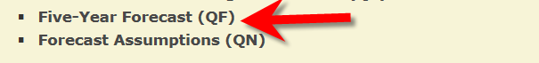

3. Click on Five-Year Forecast (QF)

4. At the top of the screen, click on “Delete ALL Five Year Forecast”

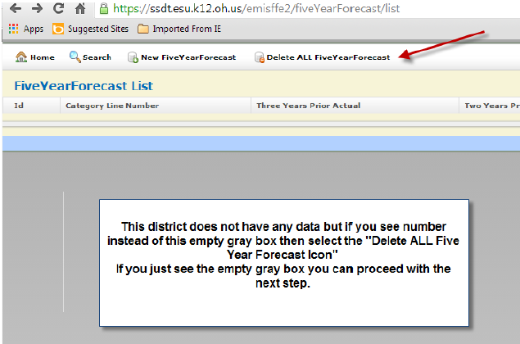

After the data has been cleared, click on “Home” to go back to the main page.

Follow the import and processing directions.